**MPU Sensor offset measurements:**

Edit code in main function:

Edit the header.h project file #define statements for each MPU sensor parameter. Set all TC_SLOPE and TC_Y_INT values to 0.0

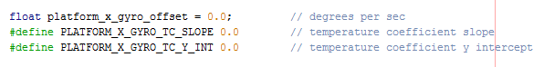

Rig MPU sensor so that it is level and not moving.

At room temperature compile and run project for approx. 10 seconds.

From watch window record the Platform MPU temperature in

Heat MPU sensor with hot air gun to elevate internal temperature.

Compile and run project for approximately 5 minutes. This will allow 300 samples to be taken at 1hz.

Open watch window

1. Set offset_buf variable “Display Value Column as” IEEE Float
2. Export offset_buf variable to csv file, displayed format. Save file in project “Offsets” directory as “MPU_Offsets.csv”.

Open .csv file saved above in Excel .

1. Copy Columns A and B
2. Paste columns into TetherQuad Sensor Offsets.xls file, Raw Data worksheet.
3. Offset formulas are automatically calculated and displayed in the “Charts” worksheet of “TetherQuad Sensor Offsets.xls file.

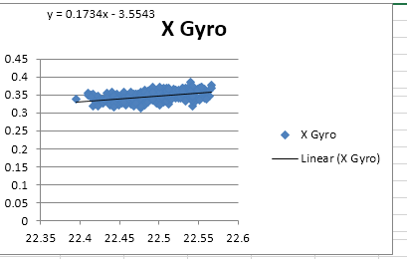

Edit the header.h project file #define statements for each MPU sensor parameter. Example below shows X gyro X and Y intercept values from chart assigned to #define values.

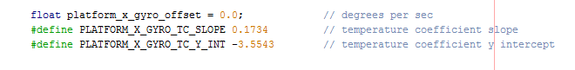

Edit code in main function:

get_sensor_offsets_enable = false;

Recompile project and run. Verify MPU sensor angles, gyro rates and accel angles are zero to confirm proper calibration.